 |  |  |  | DISTRIBUTION
PROJECT | UNR-Mathewson | REPORT # | 003
LOCATION | Reno, NV | TRIP DATE | 12/19/2023
PROJECT # | A9941.01 | ENGINEER/Observer | Anand Mourougassamy
CLIENT | LMN Architects | TODAY’S DATE | 12/20/2023
CONTRACTOR | Clark Construction | PAGE | 1 OF 7

OBSERVATIONS/ACTIVITY
Time: 11:00 am
Weather: Cloudy and 45 °F
Present: Clark Construction – Brian Peart, Chase Johnson
Magnusson Klemencic Associates – Anand Mourougassamy, Hannah Bonotto, Derek Beaman
UNR – Jeff Current

Clark, MKA and UNR walked the UNR Mathewson site to observe the reinforcement in the shear walls at Level 5 of the north core prior to concrete placement, honeycombing of the placed concrete walls at both north and south cores and perimeter wall reinforcing, as shown in Figures 1- 4.
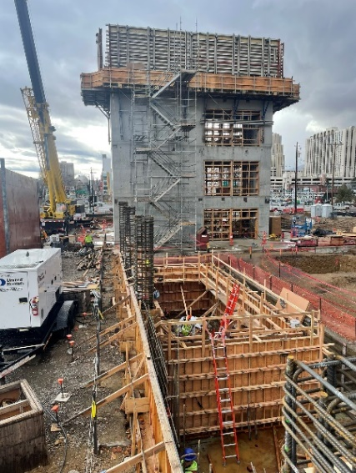
Figure 1. View looking south at south core along Grid A

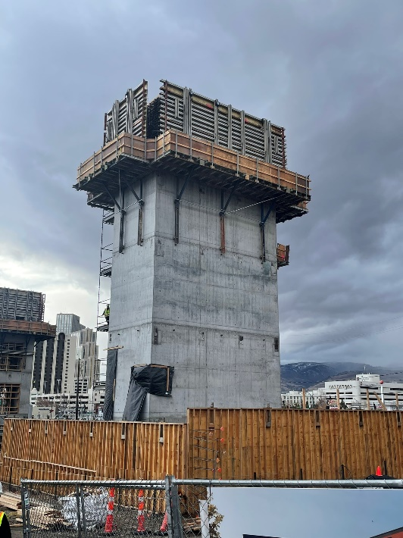
Figure 2. View looking south at north core wall

- MKA observed the in-progress reinforcement at the shear walls at Level 5 of the north core. The vertical reinforcement and shear ties were installed prior to MKA’s visit. MKA understands the slab dowel bars with formsavers will be installed prior to concrete placement. The in-place reinforcement appeared to be in conformance with the contract documents.  Action: None |  | 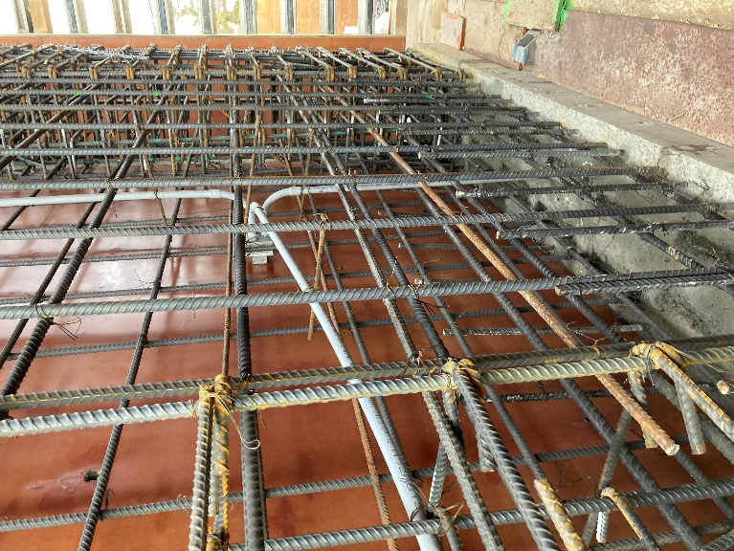  Figure 3. View of north core along grid 4
- At roof level, MKA observed the (2) #6 drag bars and formsavers for the bar extension into the metal deck had not yet been installed per S106A.  Action: Contractor to confirm the installation of the drag bars and the formsavers before concrete placement. | 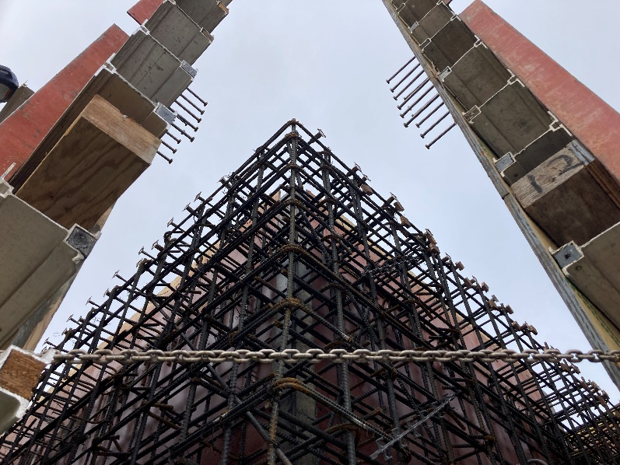  Figure 4. View south wall at Grid 4 at Roof level
- MKA observed the honeycombing of the shear walls at a few locations of the north and south core walls. MKA discussed the repair procedures with the contractor and UNR. MKA also observed repaired patches of wall.  Action: Contractor to confirm soundness of concrete and repair per approved procedures and products. | 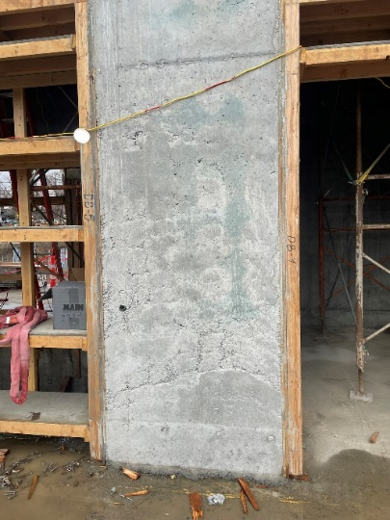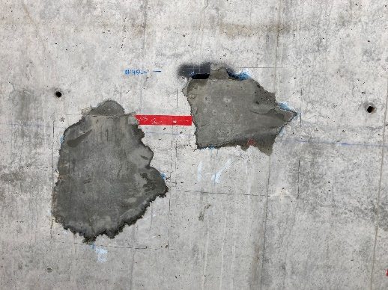  Figure 5. Concrete Honeycombing at South face of south core wall and repaired patch at North Core Wall
- MKA observed the reinforcement at coupling beams at roof level of the north core wall along north wall. MKA observed the in place ‘S2’ reinforcement (reference 18/S322) to be in conformance to RFI 238 MKA response.  Action: None | 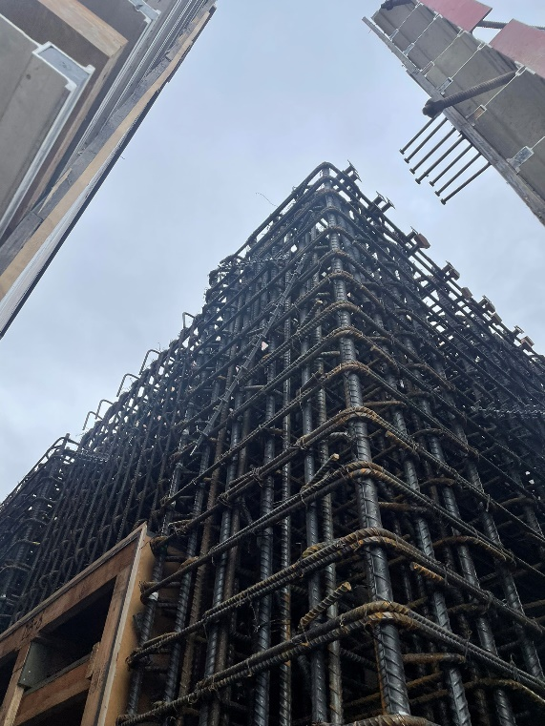  Figure 6. Coupling Bm reinforcement at north wall of north core
- MKA observed the perimeter reinforcement along grid A and D.1. Reinforcement installation was in progress. The reinforcement appeared to be in conformance with the contract documents.  Action: None. | 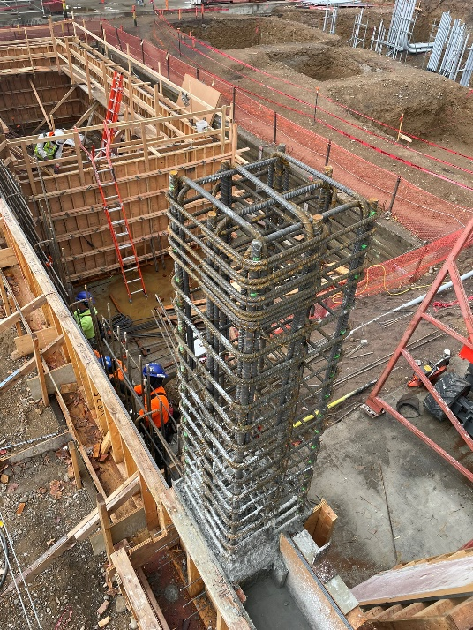  Figure 7. Reinforcement at perimeter wall along grids A and D.1
- MKA observed vertical reinforcement extending above continuous wall footing along grid AUD. The in-place reinforcement appeared to be in conformance with the contract documents.  Action: None. | 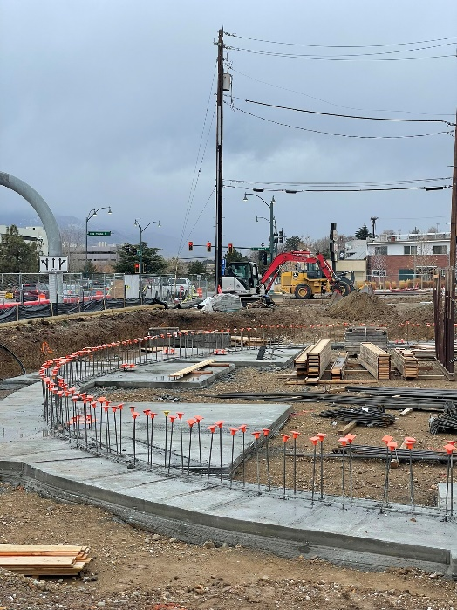  Figure 8. Auditorium Curb Reinforcement along grid AUD
- MKA observed damage to vertical reinforcement extending above mat foundation to lap with SOG at various locations between grid 11 and 12.  Action: Contractor to cut damaged vertical bars and drill and epoxy bars. Contractor to submit RFI for MKA review of products prior to drill and epoxy. | 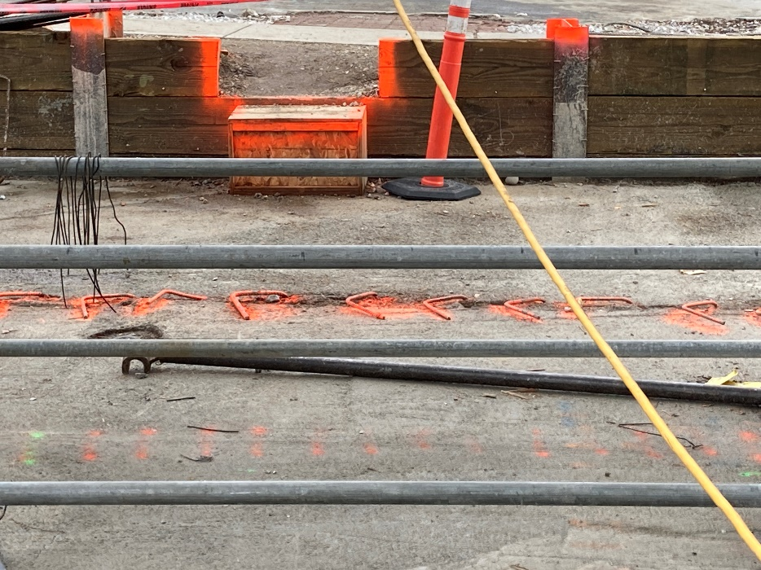  Figure 9. Damaged Reinforcement between grid 11 and 12 at SOG to Mat foundation

\\ad.mka.com\Sea\Eng\UNR_Mathewson\Construction Admin\FieldReports\20231220_UNR_MKA Construction Observation Report_003.docx

